TREVELYAN COLLEGE JCR MINUTES
JCR Executive Committee Meeting 2023
15/11/23 18:30

CONTENTS
Contents p. 1
Present & Apologies p. 1
Individual reports p. 2
Environment & Sustainability Policy p. 2
Music Bands for Winter Ball p. 5
JCR Engagement & Satisfaction Review p. 7
PRESENT
George Little President
Thomas Hewitt Vice President
Hugo Fung International Rep
Alysia Orbell Welfare Officer
Matthew Hall Welfare Officer
Kush Pandey Treasurer
Patricia Moreno-González Social Chair
Samawiya Asim Services Officer
Tennyson Godsell Publicity Officer
James Taylor Buttery Chair
Isaac Chan Clubs & Societies Officer
Akshita Singh Chair
Rosie Rochester Environment Officer

Apologies:
George Scholey Bar Sabb

INDIVIDUAL REPORTS

PMG: Winter Ball preparations are going smoothly. ENTS are mostly sorted. Only issue is with one of the food vans – we’ve had to swap and it’s a bit more expensive but I’ve put it into the budget.
KP: Is this for the deposit?
PMG: Yep. I’ll send confirmation for everything soon. The only other thing to sort is music but we should have that confirmed in a few days.

HF: I’ve planned an event on October 24th – International Movie Night, starting at 8pm in the Dowrick Suite. Kath has approved it. I haven’t decided which movie yet but I might do an online Instagram poll.

KP: Been in discussions with Monica (Assistant Social Chair) regarding the Edinburgh Trip. People have started paying for that and Live on the Hill. Subs have been coming in. I’ll also be opening TCUP soon – either next week or this week.

SA: Had a meeting with the catering team today and discussed portion sizes, introducing different cuisines and dealing with dietary restrictions. We’ve already incorporated a lot of solutions so its looking good.

AO: SHAG week was last week, and Welfare Campaigns Committee were involved with the making the posts for that, which went really well. We’ve got Welfaremas coming up. Charlie (LGBTQ+ Rep) is working on organising a Trans Vigil of Remembrance.

JT: Hiring staff is basically complete. I’ll have a chat with GL about finalising the details. HR have responded. Staff can start training soon. We’re doing alright financially but I’m a bit concerned for the long-term. I’m trying to ensure we’re covered in terms of the hygiene checks.

TG: IT have finally resolved the issues with the newsletter, so have managed to start sending ‘This Fortnight in Trevs’ out again. Other than that, I’ve been working with PMG and Ben (Assistant Publicity Officer) on promotions for Winter Ball, and have approval from Martin to start using the bulletin boards to make a physical weekly timetable in the Cobbles starting next week.

TH: Stash should be arriving soon. We’ll need to sort through them before we begin distributing it.

AS: Upcoming JCR Meeting on October 26th. I’ll send a call for motions on Monday but we have no co-inciding elections, so no husts.

IC: I spoke with KP and TH about trying to crack down on people paying JCR levy if they’re part of societies. We’re thinking of checking society execs first. We’ve looked into different options about how to resolve this.
GL: I do think we don’t want to alienate the societies too much, as we’re trying to keep them as involved as possible.
IC: Art Rep is organising an event near the end of term and we’re waiting for approval from Janice.

GL: A bit quieter this week. Been looking over Live on the Hill, Charity Ball and the pantomime. I’ve been working on Finance Committee and had various meetings with the SU and Central. I’ve set up a working group to bring up the catering changes to Jeremy Cook which is good. I’m also meeting with Karen O’Brian and it would be great if someone could join me.
TH: I can.

ENVIRONMENT & SUSTAINABILITY POLICY (Environment Officer)

RR: Basically last year there was a similar motion put out last year by the Environment Society. It wasn’t super easy to implement so I’ve edited it to resolve some of the issues last year’s exec had and have tried to make it more applicable to Trevs. I just wanted to run it past the exec before the JCR Meeting.

AS: Is the policy independent of the constitution? How did the Climate Society envision it?

RR: It was a policy that the JCR would adopt.

GL: We could trial it as a policy first before adding it to the constitution.

RR: The main changes are changing the title of Enviroment Officer to Environmetn & Sustainability Officer (ESO), shifting the focus of the role a bit. It also changes the ESO to be under the Vice President as it’s a bit more wide ranging than Services. The JCR would recognise we are in a climate crisis and emergency, which was opposed by a certain exec member last year. We’d also introduce an Eco Committee. Most of the changes would be specific to the ESO, and committing the JCR to making sustainable purchases and choices, focusing on events, stash and food waste. That’s basically it in terms of what the exec is committing too.

AS: Any questions?

TH: It’s a very impressive document. One thing that wasn’t covered was the Buttery. My thinking is we don’t have to commit the Buttery.

JT: We do have some plans. We had a chat about paper plates, but eradicating them is impossible as a lot of our business is bar crawls. We could have it so if you use your own Trevs plate you get a discount. One issue is we write orders on plates but that’s not insurmountable. Is there anything else you’d want from the Buttery?

RR: The Buttery is performing as sustainably as it can without creating massive hinderances to the business.

JT: Plates is the only thing I can think of.

RR: The only thing I can think of is having someone on Buttery Committee be responsible for thinking about sustainability.

JT: I can talk to the Buttery Committee about it and gage opinions. As long as we’re not strongly committed to something or restricted, I don’t have any issues with it.

TH: One of the other things was societies considering sustainability. It wasn’t a binding commitment, but I think you’d need to make it binding to get them to make a change.

IC: I don’t really see why all societies needing a sustainability officer.

RR: If we want to make a difference on all levels, we need to cover all our bases.

JT: We do need to be careful we don’t alienate clubs and societies, as they aren’t very pro-JCR.

IC: Not all clubs and societies have many sustainability concerns, for example, the football team.

RR: The challenge is I don’t have power as ESO to hold clubs and societies to sustainability standards. It’s unrealistic to have a sustainability officer in all clubs and societies, but there are other more practical points which could help.

TH: My thing is none of the clubs and soceities leaders are likely to read, let alone follow, the motion if its not binding. We could make it a clause when re-ratification comes around. It just means its on their radar as otherwise it never will be.

RR: I don’t think it’s a huge priority, but we’re just trying to cover all bases in terms of being environmentally conscientious.

TH: My other point is the Environment Report at the end of the year. Since handover happens at the end of Epiphany, this could be awkward as it would span the terms of two different ESOs. Would it make more sense to do this during handover?

RR: Yes, that makes sense. I’m happy to amend that.

TH: My last point is the logging of sustainability data. I assume the ESO would be responsible for this?

RR: The idea is to try to get a quantifiable idea of sustainability in college. I agree that specifics and practicialities will need to be elaborated on.

IC: How do you calculate sustainability?

RR: It is complicated. For stuff like stash, it would be using recyclable materials, or re-using decorations for events. I agree it’s very complicated, but we can determine the specifics later in the year.

TH: It might be easier to compile a list of unsustainable purchases and report it to the ESO.

RR: That would work.
GL: We could make the report less specific for now, and then we can work out how we want to do it annually.

RR: The other major point would be in the event of the ESO position being unfilled, it would take priority for exec to fill that role over other Tier 2s.

MH: I took issue with that as Tier 2s all have very important duties which we have to carry out regardless.

RR: My point here was that the original policy asked for the ESO to be Tier 1, which I have very much watered down. Last year when it was unfilled, the exec didn’t really do anything to fulfil these duties, and I do think that the ESO’s duties do need to happen. The wording could be changed though.

MH: The reason for this is potentially that the ESO role wasn’t as clearly defined in previous years.

RR: I agree there are other things that need prioritising, but it is important.

GL: While sustainability should be a priority in an ideal world, practically I don’t know how feasible it is to commit to that. For instance, roles like Sports Rep need to be done for the JCR to function.

KP: I think the ESO role sounds like its mainly holding the exec accountable, which the VP could do.

TH: As it is under the VP, who doesn’t have any other Tier 2s, it should be easier for the VP to fulfil these responsibities and sort out the report.

AS: Do you think it needs to be in your job description?

TH: I think we need to reword that part of the policy. We’d need to make changes to the VP and ESO’s job descriptions.

AS: Do you think you want to this forward on the next JCR Meeting?

RR: Yes.

AS: You can pass it as a policy and then as a motion. I would consider both as needing a 2/3 majority.

RR: The policy is quite long – how should I present it?

AS: I would focus on the important bits in the meeting but I will circulate the full policy ahead of the meeting.

GL: With the Environment Committee, you mention the SU Sustainability Co-ordinator. Are they willing to put something in to make it long-term?

RR: She’s on a part-time role now, but she’s said she’s willing to meet with every college and chair meetings in that capacity. I will confirm if it’s included in that position’s job description.

AS: Any other changes?

(general agreement with the motion and policy)

MUSIC BANDS FOR WINTER BALL (Social Chair & Music Reps)

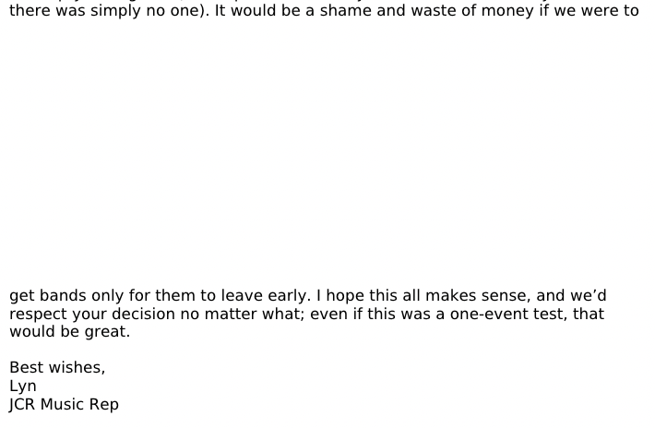
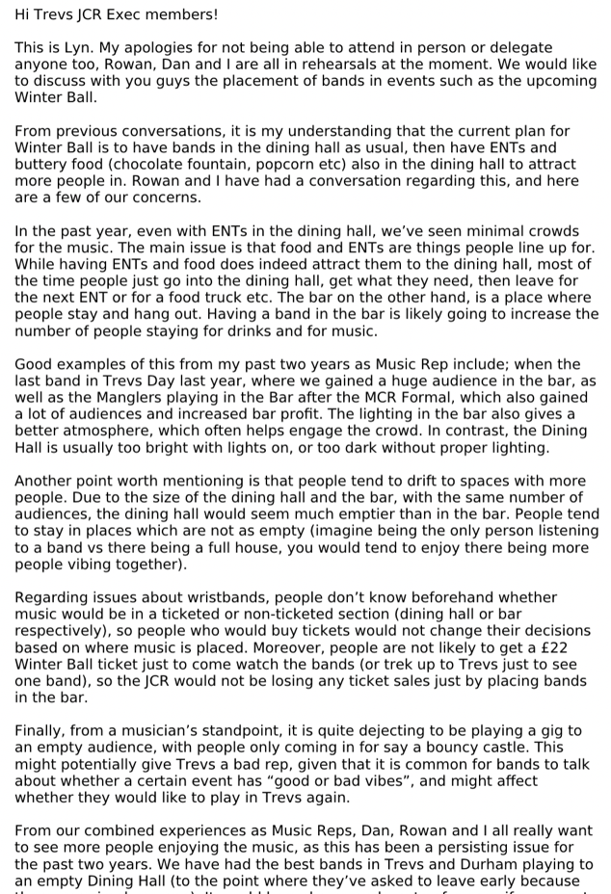
PMG: I mentioned this last week, but I’ve had a meeting with the music reps and they wanted to see if we could have the bands in the bar. Lyn sent me a document which I will circulate to you all.

AO: I worked the bar on the MCR formal, and it was super busy having the band in the bar and it was a really good atmosphere.

PMG: My only concern is the wristbands.

KP: My argument is that people are paying for the wristband. If we’re only enforcing entry to the Dining Hall and the ENTs, we’d definitely lose money. If it’s in the bar, I think music should come out of the music budget rather than the events budget. There’d be no restriction for the food vans either. Keeping it in the Dining Hall means people get what they pay for.

PMG: Do you think it would be a good idea to discuss this with the Music Reps?

KP: Yes, but we’d need to increase the music budget by a lot.

GL: We’d be decreasing the value of the ticket.

KP: We need to do it as a whole package.

TH: What ENTS have we got this year? Where are they going?

PMG: Arcade games and Extreme Arena in the Dining Hall and a dance machine in the Lower JCR. I haven’t heard back from the Pool Society President though.

GL: We do have good lighting in the Dining Hall. I think we need to have the perspective of make the Dining Hall more of a focus. We could put the Buttery and potentially have a mini bar to alleviate the queueing in the actual bar. It might be too late to do for Winter Ball, but could work in the future. We would have limited space, but I think it works better brining the bar to the music.

KP: We could just have the bar in the Dining Hall.

AS: I was going to suggest having a meeting with the Music Reps in person? Maybe with GL and PMG?

JT: I’m very conscious that they’re not able to respond at the moment as they’re busy.

GL: Yeah, we definitely need a meeting.

MH: We could try different things for events coming up to determine what the best option is.

AS: Definitely speak to GS about moving the bar beforehand.

PMG: One of the things Lyn mentioned to me is that you can’t just chill in the Dining Hall, you have to stand.

GL: We could bring in some sofas and tables from the Cobbles or the Upper JCR.

PMG: I’m happy to have a meeting with them to properly discuss it. Also if we’re not having bands in the bar, I’d like to have Tim in, so the earlier we sort this, the better.

TH: One other thing to consider is when to start the music, as it takes a while for the event to build up. Could we look at starting the music later, say at 9pm?

PMG: It was also quite empty towards the end of the night during Freshers Week. Are the Buttery happy to be in the Dining Hall?

JT: Yep, that’s fine.

AS: You said you had plans for offline publicity – we could promote the timings and music more leading up to the event.

PMG: Yep.

KP: We could get a countdown on the TV.

AS: We could put it on the bulletin board in the Cobbles.

PMG: In my experience, people haven’t been turning up for the bands.

GL: We can try to take measures, but I think making the Dining Hall more popular would be a better solution.

PMG: We can try to implement some changes for Winter Ball, and if it still doesn’t work, we can try something else for Trevs Night. I would be happy to have another meeting about it, but I’d prefer it to be sooner rather than later.

AS: Let us know in the exec chat when it is and people can turn up if they want.

KP: When are we planning to release tickets?

PMG: Friday.

GL: Let’s try to make the launch a big thing, like Live on the Hill.

JCR ENGAGEMENT & SATISFACTION REVIEW (Vice President)

TH: What I didn’t say last week was I think we do things really well, but we can try to do things better. We have the inter-exec formal next Tuesday so we can use it as an opportunity to learn about how other colleges do things and potential ways we can improve things specific to your role. Taking welfare as case study, drop ins don’t have a huge turn out. How do we improve that?

MH: The schedule is on the door, on Instagram, and the newsletter. We looked into potentially doing it via Zoom. Maybe we could try posters in the Cobbles.

TH: I just think we want it to be as easy as possible for people to find the information.

KP: Regarding the drop-ins, we could include the exec and welfare drop-ins on the ‘This Week in Trevs’ posts.

TG: Could you try to send me the schedule for that at least by the Friday or Saturday before?

MH: We should be able to.

AS: Any other thoughts?

TH: We can bring it up when we’ve got more time, but just think of any issues and we can brainstorm solutions.

PMG: Once Winter Ball is done maybe.

