TREVELYAN COLLEGE JCR MINUTES
JCR Executive Committee Meeting 2023
17/10/23 18:20

CONTENTS
Contents p. 1
Present p. 1
Individual reports p. 2
Questions for President p. 3
Elections Motion p. 3
Events Committee Motion p. 3
Any Other Business p. 5
PRESENT
George Little President
Thomas Hewitt Vice President
Hugo Fung International Rep
Alysia Orbell Welfare Officer
Matthew Hall Welfare Officer
Kush Pandey Treasurer
Samawiya Asim Services Officer
Tennyson Godsell Publicity Officer
James Taylor Buttery Chair
Akshita Singh Chair

Apologies:
Patricia Moreno-González Social Chair
George Scholey Bar Sabb
INDIVIDUAL REPORTS

MH & AO: Starting to plan Alcohol Awarness Week next week. LGBTQ+ movie night tomorrow night.

KP: Not much has changed. Just sorting reimbursements. GL and I were speaking about Gold Passes and have decided against it as they haven’t been very popular in previous years.
GL: The people who were buying it would be buying tickets anyway.
KP: Finance Committee applications should be open by the middle/end of next week once elections are done.

JT: Buttery applications are open – we’ve had about 12 so far. I had a productive meeting with Kunle the other day, and he made a verbal commitment that he’d back up the Buttery and the toastie bar. Hopefully he’ll be able to help us fight against the uni trying to make us use pre-made toasties, which is reassuring. I’ve asked him to keep an eye out for wages, as I’ve not received anything concrete about the changes happening in April. In terms of income, we’re doing better than ever, but our outgoings are also massive at the moment. I’ll review everything in a few weeks. We’ve started temperature testing toasties three times an evening to ensure health and safety standards are met.

SA: Global Formal taking place this week. Everything from name cards to post-formal activites are sorted so we’re good to go. The Diwali Formal menu has also been decided.

TH: Stash closes on Wednesday.

HF: Language café happening tonight. I’ll be setting up the games and music in the bar for the Global Formal. I was wondering if we could do an international-themed Kahoot in the bar?
GL: You can only have 10 people in a Kahoot game now, and we also have a bar night happening. You could maybe throw one in the Undercroft?

TG: Global Formal promotions went well and ticket sales were great. The addition of an Assistant Publicity Officer has really helped with managing the workload.

AS: Election nominations are open for Tier 3 positions (committees) and unfilled Tier 1 and 2 positions. We’ve not had many submissions yet, but please email anyone who showed interest during the Freshers Fair. We really need to promote.
TG: I’ll work with the Assistant Publicity Officer on it.
AS: Please push nominations and elections, especially as Tier 3 positions aren’t too much of a commitment.
KP: Are we allowed to send JCR wide emails explaining what the committees do?
AS: I included job descriptions in the elections email.
KP: We could do a more in depth one for finance. It was just an idea so people could better gage the role.
AS: If you guys could send me descriptions for your committees, I can send that out. We really need to publicise them.

GL: Parenting scheme applications are closed – we had 106 which is promising. We have around 44 families with 5 children per family on average. We’ll be meeting tomorrow to go through the applications. I’ve also been discussing Charity Ball and the Fashion Show – I think we should probably only have one as there isn’t sufficient demand for both based on Charity Ball numbers last year. There also isn’t much space on the calendar.
SA: There’s also a lot of formals in January/February, so people will be very busy.
TH: Could Fashion Show be in Summer Term?
GL: Charity Ball struggled to get numbers last year, but it was also quite close to Trevs Night and it’s a lot more expensive.
KP: Jonathan’s Voice were willing to sponsor any charity events, so that could help.
GL: I’m thinking it would be better to combine both efforts into one event. I think Fashion Show would be more unique and popular, as Charity Ball isn’t that different from other college events.
TH: From a practical perspective, the Fashion Show organisers function more as a society. How do the Charity & Volunteering Officers get involved?
GL: There’s always been a lot of JCR input with these events. If the Officers don’t want to be involved in the Fashion Show, they don’t have to be. I just wanted to check if I’m being reasonable.
KP: The Fashion Show is very expensive.
TH: I would be a bit cautious about it, and that’s the main event for Charity & Volunteering Officers. We could also consider moving the formals?
GL: Well the formal at the same time last year got cancelled due to lack of interest. Outside of this, I’ve got a meeting coming up on financial stability with other Presidents and SU Officers.

QUESTIONS FOR PRESIDENT

SA: I’ve been in touch with Gym Rep and they have a Gym Committee set up. Three of them get free gym access in exchange for their various duties (e.g. clearing up). I was also wondering if we could get a secretary for the Services Officer as the admin side of things has been very intense.

GL: Gym membership should be sorted within a few days. We can discuss the potential for a Services Secretary in more depth at the end of the meeting, as we have a lot to get through.

ELECTIONS MOTION (Vice-President)

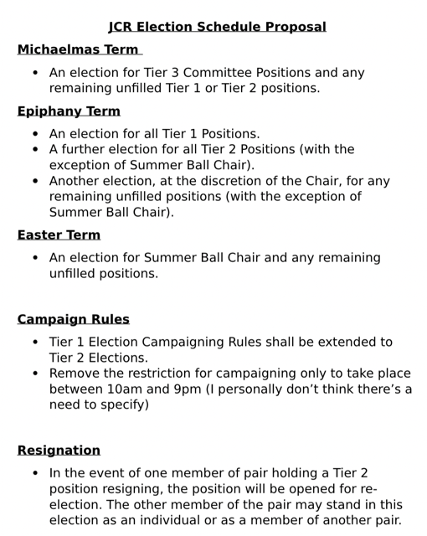
TH: The proposal has changed slightly from previous discussions. We have about 6 elections a year, and the only one we can practically cut is in Michaelmas. The main goals is to make the system more intelligible so its clearer for JCR members. Regarding campaign rules, we wanted to change this so Tier 2s can campaign to the same extent as Tier 1s, as often these elections are more contested. We also wanted to remove the time restrictions as they seemed quite redundant. We also wanted to update the constitution regarding pairs in a role and resignations, as there wasn’t a real protocol in place.

MH: With all Tier 2s in one election, it would be at least an hour of husts, and that’s if all positions are uncontested.

TH: The risk of that happening is unlikely as all positions aren’t often filled. It’s up to the discretion of the Chair how husts are done and it doesn’t have to be done before JCR meetings.
AS: We could have a hust instead of a JCR Meeting. There might a risk of less people coming in, but candidates normally bring friends with them and we don’t have a quorum we need to reach.

GL: We could also potentially do the husts after the meeting.

AS: As JCR Meetings last an hour usually, I feel that might be too long for people.

MH: If they overrun, it could impact the bar.

AS: There has been a trend of people who don’t get elected for a position running for a different Tier 2 role later in the year, so we might risk losing a lot of candidates. From a scheduling perspective, Epiphany might be too packed with three elections, as this was one of the main thing we were trying to reduce. The gap between now and January could also lead people to lose interest.

TH: I think one of the issues is if we don’t cut Michaelmas’ second election, we’ve got as many elections as we started with.

AS: We could do half of the Tier 2s in Michaelmas, and the other half in Epiphany.

TH: I think we risk losing intelligibility, and normally we get less candidates earlier in the year.

MH: Could you open nominations at the end of Michaelmas and do the election at the start of Epiphany? It could speed things up and free up more space between the Epiphany elections.

TH: In theory nominations can be advertised at whatever point.

AS: I could send out an email.

TH: I don’t think we would want an early election as people will just be settling back into Durham.

KP: We also have 14 Tier 1 positions, which would make for a very long hust.

AS: I think a potential suggestion would be to start the husts earlier (17:45 as opposed to 18:00). I can also regulate how long husts go on for.

TH: There definitely is a risk for long husts, but it’s quite unlikely to happen.

AS: My main concern at the moment is, looking at the election turnout at the moment, whether they’ll be enough engagement in just one election.

MH: A lot of people don’t think that far ahead and won’t be thinking about what they want to do next year. Having them in Epiphany seems more sensible to me.

AS: Another concern is what happens if we don’t get enough Tier 3 applications this set of elections.

TH: My idea was that the Chair can include any remaining positions in elections whenever they feel is appropriate. How do people feel about it? We need some sort of consensus.

GL: I think moving Tier 2s to Michaelmas might be a good idea.

MH: I think the best option is putting all the Tier 2s together.

GL: It could generate more excitement hopefully.

KP: I’m a bit concerned about the Tier 1s, as there isn’t much opportunity to re-open nominations if roles aren’t filled. If one of the big roles isn’t elected, it puts a lot of pressure on the next exec.

TH: I guess we’ll leave it be and see how it goes at the JCR Meeting.

EVENTS COMMITTEE MOTION (Social Chair)

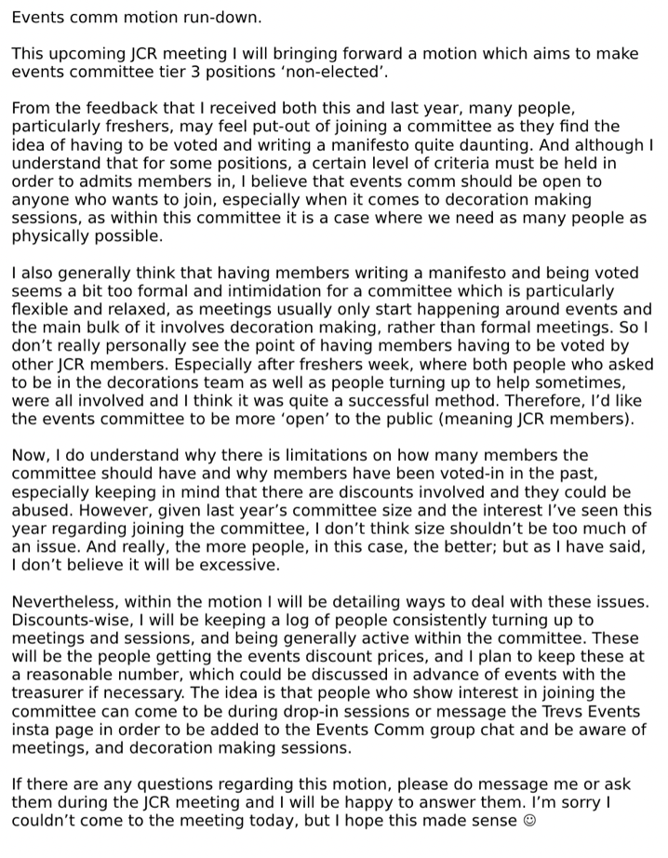
AS: PMG isn’t here but she has sent me the details. Basically, she wants to pass a motion making Events Committee voluntary and not elected, as it doesn’t really make sense to have to be elected to help out making decorations with events. Essentially, any one can join Events Committee if this motion passes, and the Social Chair will determine who gets discounts based on whether they’ve helped out for that specific events.

KP: Will PMG and I will have to discuss the discount stuff before the JCR Meeting on Sunday to make it more specific and concrete?

AS: It’s up to PMG and whether they think it will help the motion pass. How many discounts we can offer will depend on the event and how many sales we’ve made.

MH: We’d need to change the standing orders, as currently anyone in Events Committee gets discounts to everything currently.

AS: Yes, now it would be up to the Social Chair’s discretion.

AOB

SA: With the last few formals all happening in quite quick succession, I’ve been struggling managing my duties as Servies Officer and my academic work. Stuff like namecards takes a lot of time for just one person, which is why I’d like to propose making an official Services Secretary Tier 2 position.

MH: You’d need to pass a motion.

GL: What specifically would the role constitute?

SA: Other than name cards, it would be helpful to divide the workload. It took me 3 hours to do the seating plan, 2 hours to do the name cards, and another hour to sort them over the past few days. Other members of the exec helping could be another option.

AS: My only concern would be it’s hard to fill Tier 2 positions.

SA: Maybe when formals are around the corner, I can message on the group chat and a couple of exec can help out with it.

AS: I’m sure a lot of us would be able to help out.

MH: I guess the issue of it being an official position is the workload would be very inconsistent. If everyone chips in a bit, we can make the whole process a lot quicker.

KP: We can see how it goes this year, and if exec helping out isn’t sufficient, you could draft a motion to try and create the position.
MH: GL, have you made any progress with the Upper JCR booking system?

GL: Yep.

AS: Someone has booked the E Meeting Room at 18:30 every Tuesday for 4 hours. We need to find other options. Wednesday the E Meeting Room is booked from 19:30 onwards. Does Thursday work for people?

KP: We could try the Upper JCR?

JT: I think E Meeting Room is a bit better.

AS: Yes, I think the Upper JCR is a bit informal. Does 18:30 at Thursday work for people for the time being, and we can discuss with Janice about using G Meeting Room on Tuesday’s in the future?

(general agreement)

