

**TREVELYAN COLLEGE JCR MINUTES**

JCR Meeting

Sundary 6th October 2024, 18:00

**CONTENTS**

**Contents p. 1**

**Present p. 1-2**

**Exec reports p. 2-3**

**Motions**

Motion 1 p. 3-4

Motion 2 p. 4-9

Motion 3 p. 9-10

**Suggestions & Grievances p. 10**

**PRESENT**

James Koo **President**

Nathan Preston **Vice President**

Heather Lin **International Rep**

Harry Naylor **Welfare Officer**

Sarah McCutcheon **Welfare Officer**

Piper Lane **Treasurer**

Matthew Hall **Services Officer**

Monica Fu **Social Chair**

Ben Davis **Publicity Officer**

Dan Wattis **Clubs & Societies Officer**

James Gowers **JCR Chair**

Ben Cawood **Head Frep**

**Apologies:**

Freddie Farago **Buttery Chair**

**JG:** Welcome and Introduction.

**EXEC REPORTS**

**JK**: Hi everybody, if you don’t know me already, I’m James- the JCR President. Throughout the week you might have seen my running around like a headless chicken trying to keeo things in order. You’ll see that throughout the year as well. One of the main things you may have seen me talking about is the college parenting scheme. If you haven’t scanned the QR code yet please do that so that I can get the scheme going after Freshers’ Week. During Freshers’ Week, I hope everyone had fun with all the events we put on.

**SM (and HN)**: Hi everyone, I’m Sarah (and I’m Harry), and we’re your Welfare Officers. What we’eve been doing is sorting out the frepping stuff, helping out with welfare. Looking ahead to next week, we’ve got SHAG week- Sexual Health and Guidance week- so running lots of campaigns for that. (The week after that we’ve got housing campaigns running- which is probably relevant to most of you guys. This will be lead by Sarah, our Livers Out Rep and there will be lots of information to make the process as straight forward as possible).

**MH:** As Services Officer, I organise a lot of the formal stuff- everything around that. There is another one for Freshers on Tuesday so I’ll make sure some info gets sent tomorrow via email on stuff about that. You’ll sit with your subjects for that one. Also, I’ve been responding to any pantry queries- whether anything is missing or damaged. You can still email me about that throughout the year and I can help with that. Other things, there will be a catering review part way into term. This is your chance to voice your opinions about food in Trevs and then I can feed this back to staff.

**DW:** What I’ve been working on mainly as Clubs and Societies Officer is anything to do with clubs and societies. The big ones for Freshers’ Week were the Freshers Fair on Wednesday Afternoon which I hope you all enjoyed. Alongside that, there have been a couple of issues with a couple of societies that I’ve been helping. Anyone involved with societies if you’ve got any issues you can come to me!

**PL**: As JCR Treasurer, you’ve probably seen me shoving QR codes in your face to try and sell you gowns, JCR levies and all that good stuff. I’m probably going to do more drop-ins should you need to buy/collect anything.

**MF**: Hi guys, my name’s Monica, and I’m the Social Chair this year. So what I do is I organise the events within college. I wonder if you remember the club night from the Wednesday- I hope you enjoyed that. There are still many incoming events throughout this academic year. If you want to have a say/ help with any band planning/ organising and decorations then you can speak to me after the JCR Meeting or join Events Committee

**HL**: Hi, I’m Heather, I’m the International Rep. I’m really appreciative of the people that have contributed and attended the Global events that have happened recently during International Freshers’ Week. In the future, I’m going to keep supporting the International Students. If you’re an international student or if you have any problems/issues you need help with you can get in contact with me and I can help out.

**NP**: Hi, I’m Nathan, I’m your JCR Vice President. Since the last meeting, I’ve mainly been dealing with Stash stuff- I hekped the head frep Ben with getting the Frep stash. I also organised the Exec stash which arrived earlier this week. As a joint effort with the last President, George, we were successful in getting a stash drop for you guys. That’ll begin on the w/b 14th October. I’ll be sending more information out so keep an eye on your inboxes. Other than that, the Honours boards in the Lower JCR- Previous Presidents, Honorary Life Memberships etc..- I’ve been in contact with the company in getting those updated. It’ll be sorted in the next few weeks.

**BD**: Hi everyone, I’m Ben, and I’m the Publicity Officer. Recently, I’ve been mostly running the Freshers’ Instagram Account- so making sure you all known everything about college, designing the Freshers’ t-shirts- I hope you bought one of those- and just trying to make your settling in to university life as smooth as it could be. I hope you’ve enjoyed Freshers’ Week and all the events we’ve put on and the way they have been publicised. I also run the @trevsjcr Instagram account so publicising the day-to-day life of the JCR, and the JCR website.

**JG**: For myself, most of what I’ve been up to since the last meeting is running around Durham singing to anyone that will hear me. Going forward, I’m opening up elections in about two weeks time- so elections for comittees and any unfilled tier 2 positions. Before that, I have to add every single one of you who’s just joined to the mailing list. In w/b 21st October, elections will get underway. I’ll be in contact- you guy will get quite sick of my emails quite quickly.

**MOTION 1: AMENDING ONE OF THE ASSISTANT WELFARE ROLES**

*Proposed by: Sarah McCutcheon*

*Seconded by: James Koo*

**SM:** Hi. What this motion is essentially doing is changing the name and role of one of the Assistant Welfare Positions to that of Assistant Welfare Campaigns Officer. This job would focus on the running of campaigns throughout the year. This role would not involve the officer running drop-ins. This means the attention of the Assistant Welfare Roles would be more focused on different areas. This would be implemented from next year- so not affecting this year’s Asisstant Welfare Officers (AWO).

The JCR notes that it would be useful to have two tier 2 welfare roles specifically for helping with campaigns. It would be good to have someone who’s role is specifically dedicated for that. When there are two AWOs there can be some confusion about the specific roles of the job. It would be useful to have one officer dedicate their attention towards campaigning. Some might not want to run drop-ins.

(SM read out the ‘This JCR believes’ and ‘This JCR resolves’ sections exactly)

**JG**: Any thoughts or questions that they would like to bring forward and ask Sarah about this?

**Question 1:** Would there still be drop-ins?

**SM**: Yes, there would still be drop-ins. Just because we’ve got the entire team doing drop-ins. This would just mean one fewer person running drop-ins- who would focus on campaigns. Because we’ve got a big enough team we likely don’t need as many people.

**Question 2:** If you delegate out some of the responsibilities of the welfare team to specific roles could it not damage the effectiveness of the team as a whole?

**SM:** We have a Disabilities Rep, a Working Class Rep etc.. and they have their specific roles. The reason we have two Welfare Officers is because it was changed in the constitution. It doesn’t necessarily make sense to have two AWOs as well. It would make more sense to separate the responsibilities of the AWOs out.

**JK:** Making this change would alleviate some of the stress and workload off of other Welfare roles which would be beneficial.

**Question 3:** I was wondering why you could’nt create an entirely new AWO role?

**SM:** We’ve got a big welfare team as it is- many aspects of the tier 2 AWO roles don’t need two people. Giving drop-ins to one AWO and campaings to another very clearly defines their responsibilities and it would improve the overall operation&dynamic of the welfare team. Still having the same numner of welfare teams but just more clearly defining roles and responsibilities.

**MOTION PASSED BY VOTE**

**MOTION 2: WELFARE VETTING MOTION**

*Proposed by: Sarah McCutcheon*

*Seconded by: James Koo*

(**SM** read out the following with no deviations)

**JK:** The reason we want to introduce this is because we realise that welfare positions are sensitive regarding the information imparted to them involving students. So, for example, you may come across, in the course of a welfare position, sensitive information pertaining to a student’s wellbeing or mental state. Obviously, you don’t want just anybody to have access to that information- they may not have the best intentions nor be able to keep such information confidential. We would like to trust that they can but it’s a precarious balance. One slip up and the whole system could be scrutinised or put to an end. This is why we want to be proactive in preventing that situation instead of being reactive. Quite frankly, we’re surprised this hasn’t already happened. With the vetting system, its more of an informal system just to lay down the groundwork and to establish what the role of welfare entails.

(**SM** read out the following with no deviations)

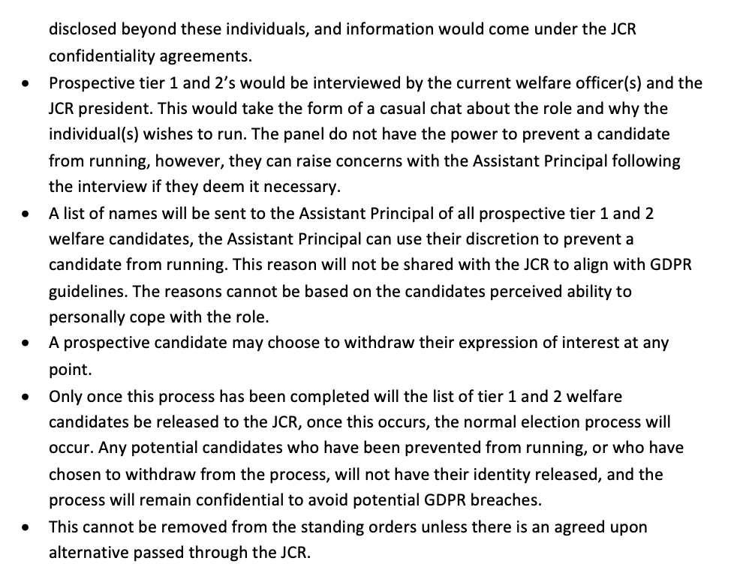

**SM:** Sorry that was so long

**JG:** With that in mind, would anyone like any clarifications?

**Question 1:** Why was it [the vetting system] removed in 2023?

**SM:** Essentially, it was removed in 2023, because it was a vetting system opereated by the JCR for anyone running for any positions. It was illegal. Theoretically, someone could’ve taken us to court and we didn’t want that to happen.

**JG:** Essentially, how it worked, was that Steering Committee, was in charge of vetting. That was in their job description. The committee convened to discuss whether a candidate was able to go forward or not. That left us a little bit open to some legal loopholes that may not have been beneficial to the JCR. We made the decision that it would be better to remove that and bide our time to figure out the best system going forward. For roles such as welfare, this is what the welfare officers have come up with now.

**Question 2:** [Not picked up on either the Voice Memo or Facebook Live]

**SM:** I’ve been having meetings with Hannah, the Assistant Principal, and Martin, the Vice Principal, since before exams last term so I’ve worked heavily with them. This is a very much agreed upon plan with both officers. In the previous system, college would not discuss vetting with the JCR but luckily with this proposed system, they are very happy to work with us. Also, we’ve talked to our Assistant Principal who has talked to other Assistant Principals about our vetting system- they have collectively said yes.

**Question 3:** First of all let me say that I’m not necessarily disagreeing with what you’re doing. What I want to raise it that, from the presentation of this vetting system, it still very unclear what kind of system it is. Is it a DBS check or something like that? You said that the panel would not have any power- is it necessary? If the college were to decline a candidate, would this be breaking the student code of conduct for Durham University? I’m not against the vetting system, I just have a few questions about how it would be implemented.

**SM:** Going through those, the panel does not have any power but again just to make sure that we [the welfare team] are not making any decisions arbitrarily. This takes the form of more of a casual chat- so talking about the job. The list of names will go to the Assistant Principal and they will be able to stop candidates should the feel the need to- they have access to more information that we don’t. Durham University can’t really do DBS checks. Again, that was something I discussed with college, but we are not able to do that. Again, going onto your point about whether this would breach the University’s policies, this is something we might not know because it may not have been- it may have happened outside the university. We’re at a difficult stand of what we can do. It’s more to talk about the role and what we want to do with it. What the paenl can do is they can go to the Asssitant Principal with any specific concerns and raise the candidate specifically. Again, the welfare, we really do think it needs to get through as soon as possible just because of what we do and the fact that, we’re listening to disclusures of sensitive natures. It’s essentially, we want to make sure we have as a much secutiy as we can. It is frustrating and I understand there’s a lot more that we want to get across but because of university and college guidelines there’s not masses we can do. This is what we are allowed to do and what we’ve talked to college about. It’s not everything we could do and would want to do but it’s the best we’ve got at the moment.

**JG:** Does anyone else have any questions?

**Question 4:** This is less about the motion itself and more about the fine clause- is there precedent in the constitution to have ‘this cannot be removed from the standing orders unless there is an agreed upon alternative passed through the JCR’. I get why it’s there-I’m more flagging is it in keeping with how the rest of the constitution operates?

**JG:** As far as I’m aware [subject], there is no precedent for that to be in the constitution or the standing orders. There’s nothing concrete in the standing orders that says ‘this cannot be removed unless..’. I guess that was the issue with the first system because there wasn’t a clause requiring a replacement should it be removed from the constitution. We didn’t know what the best course of action was at the time.

**SM:** We don’t want it to potentially be removed and then have a need for it. We want to make sure there is always something in place. We want to make sure at all times, given the sensitive nature of welfare, there is always a vetting system in place.

**Question 5:** Why should we not vet all of the exec, all Tier 2’s and maybe Tier 3’s. At the end of the day, all JCR roles carry some responsibilities. I get it for the welfare team, but why is this motion not on a bigger scale for introducing it across the JCR? Any role with a degree of responsibility has a scope for causing harm so why should they not all be vetted?

**JK:** The reason we’re running it for welfare specifically it because it’s quite a personal thing for the welfare positons. Certain roles are a lot less ‘powerful’- they have a lot less that could go wrong for them. For example, Clubs and Societies, the most that could go wrong is annoying a club/society- that’s the worst that could happen. The worst that could happen for welfare- you can probably figure that out yourself. The same goes for tier 2 positions except the AWOs- which again, I’ll leave to your imagination. We understand that the idea of a vetting system across the JCR would be a good thing however it was flawed in the past. We need to bring it back for welfare urgently. Should it work for this, we can maybe look at removing this system and implementing a wider-reaching, better system. Until then, this is the best we could come up with within guidelines, remit and college backing.

**Question 6:** The president deals with issues that are, at times as sensitive as those managed by the welfare officers. Would it make sense to amend the motion to include the president, in addition to the welfare officers, within the motion?

**JK:** I agree that President deals with a lot of issues of a sensitive nature. However, I think that with the role of President, you have a lot more connection to college. They are aware of who you are as soon as you become president-elect. College are already contacting you with details of who you are etc.. I suppose it would be worth potentuially amending it but, its one of those things where I’m not sure how necessary it would be.

**SM:** This specific system may not work well for the President in terms of who is on the panel. Whilst the idea of president-vetting may be valuable, this specific system might be difficult to implement.

**Question 7:** Surely if this isn’t suitable for president then it sort of admits there’s an inherent bias to this because, if you’re saying that everyone in college will contact the president-elect, then they don’t need to be vetted- does that discourage those who go for welfare who aren’t known by the college? If you’re being vetted by a panel of people on the JCR then they’re inherently biassed. Whereas college aren’t necessarily biassed- they have more of that neutral line. If you’re being vetted by the JCR, people are going to have their own opinions about candidates and who they think should run for welfare. I don’t understand why, if the JCR panel has no power to make a recommendation, why is it not just the college staff (Assistant Principal) who’s doing this. It seems like we’ve got some sort of bias.

**JK:** Sorry, I should’ve worded myself better. On the point of college knowing who you are as president-elect. I meant that once you go for it, the college are already made aware of who you are in terms of the nomination and election process. They themselves will take a look into who that person is. I agree in principal that if we want to role out this vetting system to welfare then it should be rolled out for the president as well- I would be happy to make an amendment.

**JG:** So you would be happy to amend it [the motion] to include the President as well?

**JK:** Yes

**Question 8.a:** Mine’s kind of on the same line as [Question 7]. Why have some of our peers, who haven’t been vetted, got the power/influence to sway the Assistant Principal. I don’t really understand why the welfare officers need to be there if the Assistant Principal is just making these decisions.

**SM:** Speaking to the Assistant Principal, she said that having a direct conversation with the proposed candidate would go against contractual obligations. It would therefore need to be a more indirect line, through the welfare officers, to the candidates.

**Question 8.b:** So you’re saying that non-vetted JCR members would be vetting prospective welfare officers?

**SM:** Essentially, we’re hoping that as we go into the future, all welfare positions would be vetted. The vetted ones could then sit on the panel.

**Question 9:** Is there provision, for example if, a welfare officer is sitting for a second term? From what I can see, the welfare officer would be required to sit on both sides of the panel.

**SM:** That would probably be something we would discuss with the Assistant Principal, the JCR chair and the candidate.

**Question 10:** How would this vetting operate with regards to the new Assistant Welfare Campaigns Officer (see previous motion)? With them not running drop-ins and thus not being imparted with such sensitive information, would they have to go through the exact same process?

**SM:** We didn’t know that motion would go through prior to having this discussion and submitting this motion. We thought potentially, they might be vetted as well- just to have that uniform policy across the tier 1 and tier 2 welfare positions.

**JG**: It seems to me from what people have been saying, that the biggest sticking point to thus is the panel. Earlier in the motion it was talking about how other colleges have the list of names sent to the Assistant Principal. I’m just thinking about ways in which people’s concerns could be addressed. Do you think an amendment where the panel might not be necessary but the names still go to the Assistatn Principal would be beneficial.

**SM:** I still think the interview with the incoming canditdate is a good way to have a chat and discuss the role and responsibilities. It allows them to have a better idea of what they’re getting into. You go into it without appreciating the amount of work that goes into it. Again speaking to the Assistant Principal and other colleges they’re quite keen to bring in this system across the colleges anyway.

**Question 11:** Do the welfare positions, being elected, not already serve as a layer of vetting, having the JCR as a collective decide on whether to elect the candidate into their position?

**JK:** You’re correct that it is an elected position and there is discussion amongst the students themselves. However, with that, not every student will be best-versed in what welfare entails and the details of the candidate. The Assistant Principal will have a lot more of a deeper understanding of any issues that might need to be looked at or raised and, that’s information that won’t be available to the wider student body in the first place.

**JG:** Any more thoughts? We’ll have one final thought and then go to voting.

**Question 12.** Fantastic idea but the more and more I listen to this motion. I just want to ask, why have we not considered taking systems that have been created in other colleges. Why have we not adapted those and adopted them to Trevelyan College. The JCR exists as an independent body from college- are we not starting to merge with college in terms of becoming more reliant on them and compromising the JCR/ student’s voice. I’m just playing devil’s advocate but could we not adapt one of the other college’s systems for our own.

**SM**: So none of their structures, when we were looking at it- they’re not official. The way they do it, its not in their constitution. It isn’t enough what we have at the moment and nor what they have. We failed the Mental Health Charter last year- the University failed the Mental Health Charter. We’re looking at fixing that via this setup that we’re looking to establish across the colleges. Right now there’s nothing in place and the college welfare system is very vulnerable. We’re all very concerned about it and so are the wider presidents and welfare officers. What is in place in any college at the moment is not enough so we’d like to make sure something better is in place.

**JG**: Thank you. Thanks to everyone for sharing their opinions on that. I think we’re going to go to voting. This is a motion that would change the standing orders of the JCR, therefore it needs 2/3 approval from everyone here to pass. You can abstain as well but if you abstain this doesn’t count towards the 2/3 of people who are here- abstaining is essentially saying no.

**MOTION FAILED TO PASS BY VOTE**

**MOTION 3: FREP THANK YOU MOTION**

*Proposed by: James Koo*

*Seconded by: Sarah McCutcheon*

**JK:** On a lighter note, this is the Frep Thank You Motion. The Freps have been running around in their blue jumpers and white t-shirts the entire week, planning events and welcoming you, making tiktoks. I think it’s a good chance to give a special shoutout to a few people. I’d like to thank the Exec for all the work they’ve been doing [applause], the publicity team [applause], the decorations team [applause] and all the various tier 2’s and all the other freps who have dedicatd their time for the last two weeks and maybe longer. Ben do you want to come up and saw a few words, as our head frep?

**BC:** I just want to say a big thank you to everyone. Its been a great Freshers’ Week for both the Freps and the Freshers. The attendance at events this week has been phenomenal, particularly the bop where we 220 out of 234 of you with a ticket. Brilliant attendance. I hope you really enjoyed it. The frep team have put in so much hard work, many of them have been staying up to 3am this week. I don’t remember the last time I went to bed before 3am. I really want to thank them for their hard work over the last two weeks and over summer when they were planning things as well. A big thank you to them.

**JG:** Does anyone have any thoughts or should we just go straight to voting

**MOTION PASSED BY VOTE**

**SUGGESTIONS AND GRIEVANCES**

No suggestions or grievances.

BC spoke about Freshers’ feedback form.